Journal topic (style: prgTopic)

UDC 000.000.0 (style: prgUDC)

the paper title
for the journal "Programming"
(style: prgHeader)
© 2021 Ivanov I.I^{a,*}, Petrov P.P.^{b,**}
(styles: prgAuthor^{prgMailRef***})
ªInstitute for System Mathematics, RAS
4, Pravay square, Moscow, 111111, Russia
^{b}Institute for Applied Programming, RAS
1, Otkrytaya str., p. Priozerny, Primorsky kray, 222222, Russia
^{c}Global Algorithms, PLC
1014, Barranca Mesa, New Mexico, 333333, USA
(style: prgAffiliation)
∗e-mail: ivanov@box.int, ORCID: 0000-0000-0000-0000
∗∗e-mail: petrov@box.int, ORCID: 0000-0000-0000-0000
∗∗∗e-mail: sidorov@box.int, ORCID: 0000-0000-0000-0000
(styles: prgMail, prgORCID)
Received: 01.07.2021
Revised: 16.08.2021
Accepted for publication: 25.09.2021
(style: prgDate)

The volume of the abstract should be 200-300 words. The abstract should not contain references to literature, abbreviations (if possible), unnecessary introductory phrases and complex grammatical constructions. The abstract should describe the main objectives of the work, explain how the study was conducted (but without unnecessary details), summarize the most important results and their significance. The abstract should be self-sufficient: it should not contain phrases like "the results obtained are described in the last section of the article" — the results should be briefly described in the abstract itself. Annotations are welcome, the structure of which repeats the structure of the article and includes in a concise form an introduction, goals and objectives, methods, results and conclusion. The various components of your article (article title, authors, part titles) are defined in the style sheet. You can see examples in the design of this template. The design style of each component is indicated in red. (style: prgAnnotation)

DOI: 10.00000/D0132456789012345

1. Introduction (style: prgSubHeader-2-level)
The introduction is the very first section of the article. It describes the situation in the subject area, the setting of the problem, and the directions of research that the authors intend to describe in their article.

2. main sections
The main text of the article is completely determined by its authors. It depends on the task set by the authors, the success of their research, the authors' intentions to develop the results they have obtained.
The following material will help you to prepare the text of the article for the academic journal "Programming" and its translated version «Programming and Computer Software». The Microsoft® Office Word 2016 editor version (64-bit version) was used to prepare the material. (style: prgText_main)
In order to avoid errors in the formatting of the text of the article, it is strongly recommended to use this document as a template. This will allow you to get all the specified text formatting options automatically. Otherwise, you must independently ensure that all the requirements of this document are met (page size, margins and indents, font, column spacing, etc.).
The journal "Programming" publishes only original articles that have not previously been published in other publications. The volume of published articles, as a rule, should not exceed 20 pages.
Articles published in the journal "Programming" consist of the following sequentially arranged elements, the content of which (with the exception of information about the dates of submission, revision and acceptance of the article for publication) are determined by the authors of the article:
- journal topic (see actual topic list on the journal Editorial Board site: https://www.ispras.ru/en/ programming/topics.php); (style: prgUList)
- UDC;
- title of the article;
- initials and surnames of the authors;
- full name and address of the organization (with mandatory indication of the country and city);
- e-mail addresses and ORCHID IDs of all co-authors;
- dates of submission, revision and acceptance of the article for publication;
- annotation;
- key words;
- DOI identifier (set by the editorial office and publisher);
- the text of the article;
- list of used publications (section "References") (style: prgUList).
At the end of the article, the title of the article, initials and surnames of the authors, e-mail addresses of the authors, full names of organizations and their addresses indicating the city and country, abstract and keywords, as well as a list of "References" in English should be given.

3. Formatting overview
This section describes the characteristics of the styles used in this document.

3.1. Font requirements (стиль: prgSubHeader-3 level)
General design requirements:

- the main font is Times New Roman;
- font for headlines – Times New Roman;
- line spacing — single;
- the main font size is 11 pt.;
- paragraph indent is 15.75 pt. (0.56 cm), paragraphs are not separated by a blank line;
- alignment "by width".

The title of the article (the title of the first level) is entered in capital letters in bold font Times New Roman size 12 pt. The center alignment is used for the title of the article. For the headings of the first level, the paragraph interval is set with the values "Before" 7.35 pt., "After" 0 pt. Blank lines before and after the headings of the first level are not placed.
The headings of the second level (these include the titles of the sections of the article, the first of which should be the "Introduction" section, and the last — "Conclusion") are entered in bold Times New Roman font size 11 pt. The section headings are numbered with a dot after the section number (1., 2., etc.) and are centered. For second-level headings, the paragraph interval is set with the values "Before" 9 pt., "After" 6 pt. Blank lines before and after the second-level headers are not placed.
The headings of the third and fourth levels (the names of subsections and paragraphs of the article) are entered in bold italic font Times New Roman size 11 and 10 pt. respectively. The headings of subsections and paragraphs are numbered without a dot at the end of the number (1.1, 1.1.2, etc.) and are centered. For the headings of the third and fourth levels, the paragraph interval is set with the values "Before" and "After" 6 pt. Blank lines before and after the headers of the third and fourth levels are not placed.
The presence of headings of the fifth and higher levels in the article is not encouraged. If they are necessary, the author decides on the design. In any case, such headings should not be numbered, but otherwise should be built according to the rules for formatting headings of the fourth level.
The first line with the initials and surnames of the authors is placed in the paragraph with an interval "Up to" in 6 pt and is not separated from the title of the article by a blank line. For lines with the authors' surnames and initials, a bold Times New Roman font of 12 pt in size is used on consecutive lines that are aligned in the center.

3.2 Page margin design
The article must be prepared for A4 paper (21cm x 29.7cm or 595.23 pt x 841.8pt). Page margins sizes:

- Top: 2,37 см (67.05 пт)
- Bottom: 2,79 см (79.1 пт)
- Left: 1,5 см (42.5 пт)
- Right: 1,5 см (42.5 пт)
- Binding (left) 0 (style: prgUList)

3.3 Text columns design
The main text of the article (everything except the first-level title, information about the authors, the annotation and the DOI specifier) is entered in two columns of the same width with the parameters:

- First column: 8,75 см (248.1 пт) (style: prgNList)
- Interval: 0,5 см (14.1 пт)
- Second column: 8,75 см (248.1 пт)

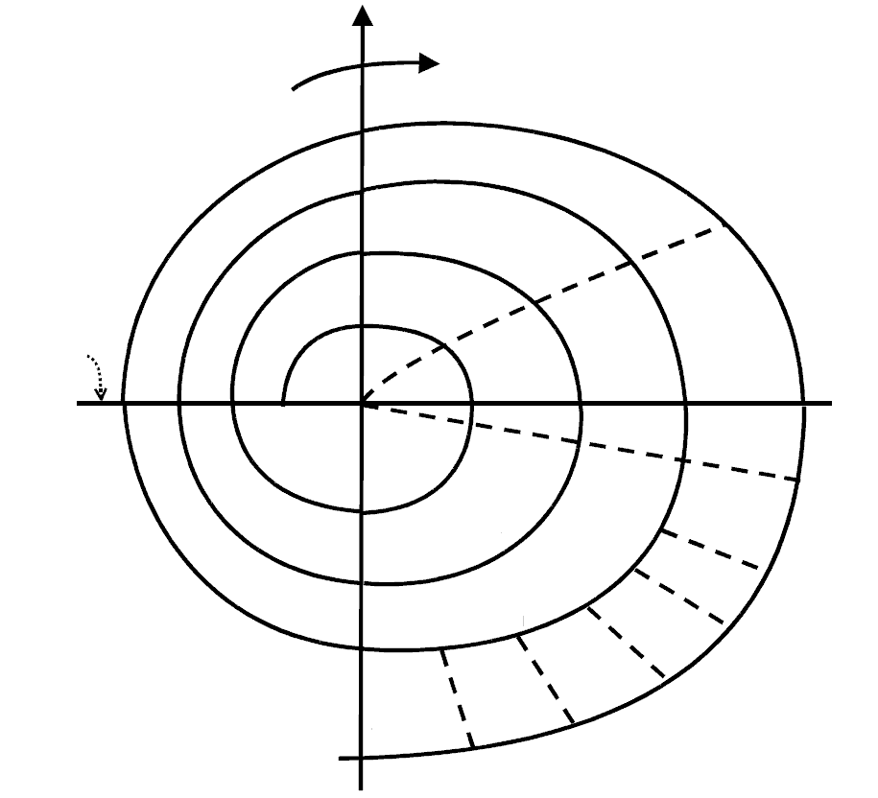

Workflow
Evaluating reviewers' suggestions, clarifying article drawbacks, and identifying options to address them

Total cost of paper preparation

Planning co-authors’ tasks, alternatives, limitations

Drawback analysis

Paper new version submission

Drawback analysis

Drawback analysis

Paper working draft

Paper draft

Paper requirements

Updated Table
of contents

Table of contents draft

Detailed paper plan

Requirements planning

Paper concept

Proposals
for sections
and fragments

Internal expertise
Requirements improvement

Text planning

Text preparation

Writing
fragments

Data check

Text consistency checking

Completeness check
Planning next text iterations

Full text
forming

New paper submission

Final paper
reading

Writing next paper version

Fig. 1. Technological process of paper preparation. (style: prgPicture_sign)

3.4 Paragraph design
Alignment of paragraphs follows the common practice – in the main text "in width", in the headings – in the center. The margins and spacing for different styles may be different, but the main text is designed with a single line spacing (style: prgText_main).

3.5 Figures and tables
If the text of the article uses figures prepared outside the Microsoft Word or Open Office environment (including mathematical formulas), they should be attached to the text as separate files (in JPEG, GIF, PNG formats) and be of a sufficiently high quality. If there are many such files, it is recommended to create an additional text file-catalog connecting the names of these files with numbers of figures or positions of formulas in the text of the article.
If a figure or table is of considerable size and it is impossible to place them in columns of text without losing clarity, it is allowed to format them in one column (Fig. 1). Such one-column sections, containing only (!) Figures and / or tables, must be placed at the beginning or at the end of the page. It is recommended to place small figures and tables among the text without switching to one-column mode (Fig. 2).

Fig. 2. PERT-diagram.
When making figures, it must be remembered that color drawings should not lose their visibility when they are transfered into black and white format.
The captions under the figures and the inscriptions on the figures are made in two languages - Russian and English.
The captions should begin with the text of the form "Fig. 1" ("Fig. 1"), made in bold, ending with a dot and aligned in the center. The caption is executed in Times New Roman font size 10 pt.
If there are tables in the article, a supertabular caption in two languages is placed above the table, begins with the text of the form "Table 1" ("Table 1") and is not aligned. References to figures and tables in the text of the article should have the form "Fig. 1" ("fig. 1") and "table 1" ("table 1"), respectively.

4. Publisher Recommendations
Journal self-citation refers to links to scientific articles by any authors previously published in the journal to which this article is sent. The indicator of the level of journal self-citation is taken into account when considering the inclusion of the journal in international scientific citation databases, such as the Scopus and Web of Science databases. Too high a journal self-citation level is an obstacle to the journal's inclusion in these databases. When preparing the text of an article, it is important to follow the recommendations of the publisher, aimed at reducing journal self-citation:

- If the author can refuse a link that increases the journal self-citation without prejudice to the presentation, this should be done.
- If instead of citing your works, it is enough to write “in my works” or “in our works”, this should be done.
- If a link to other authors is needed and there is a choice – to refer to another journal or to the same one where the article is sent– then you need to choose only another journal.
- If for the presentation it is necessary to refer to the same journal where the article is sent, then instead of a link in the text you can write according to the following pattern: "see the works of V. V. Smirnov in this journal for 2019." It will be easy enough for readers of the article to find such works.
- Finally, there are situations in which an exact reference is absolutely necessary. For example, in the case of borrowing or quoting. In such cases, you will have to provide a link in the way it is usually accepted in the journal.

5. CONCLUSION
In the final section of the article, the authors summarize the results of their work, summarize the results obtained, and outline new goals for further research.

6. ACKNOWLEDGMENTS
The general rule is to have a section in which the authors thank their colleagues who are not co-authors of the article, but who influenced the receipt of the results described in it, as well as organizations that assisted in conducting the described research.

Table 1. Paper preparation main stages. (style: prgTableHeader)
Article preparation stage | Duration | Explanation
Article concept | 2 weeks | Audience selection and key messages to include in the article
Work planning | 3 days | A preliminary table of contents of the article creation
Draft version | 1 month | Writing the main text of the article
Expertise | 6 weeks | Peer review of the article by colleagues and administration
Text writing | 1 month | Elimination of comments and writing the full text of the article
Submission of an article to the journal | 3 days | Formatting the text according to the rules of the journal and sending the text

7. FUNDING
Many organizations that funded the research described in the article insist on mentioning this in a special section of the article.

REFERENCES (STYLE prgSubHeader-2-level)
Particular attention should be paid to the correct design of the list of used literature and relevant references to sources within the article. The list of references should be constructed from bibliographic references to the publications used, the list is numbered in the sequence of using the reference to the corresponding source in the text of the article (that is, the first in this list should contain the bibliographic reference first mentioned in the text of the article). To refer to the source in the text, the number of the corresponding bibliographic reference in square brackets is used. At the same time, the author's self-citation should not exceed few percent of the total size of the article.
For individual items in the list of references, the Times New Roman font is used with a size of 10.5 pt. on consecutive lines that are aligned in width.
Bibliographic references should include the following data:

- For a book - surnames and initials of all authors (in italics); full title of the book; the name of the publisher and the city in which it is located; the year of publishing; the number of pages in the book;
- For articles - surnames and initials of all authors (in italics); full title of the article; name of the journal, newspaper or collection in which the article was published; year of publication, publication time identifier (for the newspaper - issue number or release date, for the journal - year, volume or issue number, series), page numbers occupied by the article (initial and final). If the DOI (Digital Object Identifier) is known for the publication, it should be placed at the end of the link (for example, doi: 10.1134/S03617688060400). For all articles in "Programming and Computer Software", as well as for articles from the journal "Proceedings of the Institute of System Programming of the Russian Academy of Sciences", starting from issue 22, there are such identifiers. If the article is in the Scopus abstract database, then it is necessary to take data from the article itself.
- For standards — the name of the standard, the number of the standard, the place and year of publication, pages;
- For patent documents — the name of the invention; patent number; country, number and date of the application for the invention, date of publication of the patent; number of the bulletin of inventions, pages;
- For dissertations - the surnames and initials of all authors (in italics), the full title of the dissertation; for which academic degree the dissertation is submitted; the place and year of defense of the dissertation; the number of pages of the dissertation;
- For electronic resources on the Internet - the surnames and initials of all authors (in italics) (if they are known), the full title of the material, the full email address (for example, http://www.ispras.ru/ru/proceedings / authors.php ), date of publication or creation, date of circulation (if it is impossible to set the date of publication or creation).

The titles of books, articles, other materials and documents published in a foreign language, as well as the names of their authors should be given in the original transcription. The list of used literature should not include unpublished materials or materials that are not in the public domain.
Examples of the design of the list of references:

- Ермаков М. К., Вартанов С. П. Подход к проведению динамического анализа Java-программ методом модификации виртуальной машины Java. Труды ИСП РАН. 2015. Т. 27. № 2. С. 23–38. DOI: 10.15514/ISPRAS-2015-27(2)-2. (style: prgLitList)
- Lattner C. LLVM: An Infrastructure for Multi-Stage Optimization. Master’s thesis, Computer Science Dept., University of Illinois at Urbana-Champaign, Urbana, IL.
- Ватазин А.В., Карпов Л.Е., Сметанин Ю. Г., Юдин В.Н. Программная система поддержки врачебных решений с гибридной архитектурой на основе правил и прецедентов. V Троицкая конференция "Медицинская физика и инновации в медицине (ТКМФ-5)", Сборник материалов. 2012. Т. 2, С. 425-427. РАН, Троицкий Научный Центр, ISBN 978-5-89513-272-2.
- Proskuryakova L., Meissner D., Rudnik P. The use of technology platforms as a policy tool to address research challenges and technology transfer. The Journal of Technology Transfer (online). http://link.springer.com/article/10.1007/s10961-014-9373-8#/page-1, 12.02.2016.
- Mishra P., Dutt N. (Eds.). Processor Description Languages. Systems on Silicon. Morgan Kaufmann. 2008. P. 432.
- Naveh Y., Rimon M., Jaeger I., Katz Y., Vinov M., Marcus E., Shurek G. Constraint-Based Random Stimuli Generation for Hardware Verification. AI Magazine. 2007. Т. 28. № 3. P. 13-30.
- Dijkstra E.W. A Discipline of Programming. Prentice-Hall, 1976. 217 p.
- Свиньин С.Ф., Попов А.И. Финитные базисные функции в задачах формирования выборок сигналов конечной протяженности. Труды СПИИРАН. 2015. № 43. С. 50-67.

ATTENTION: do not forget to remove all our notes given in red color from the final version of your article. Text shown in yellow will be changed by the Publisher.

